

**Model Development Phase Template**



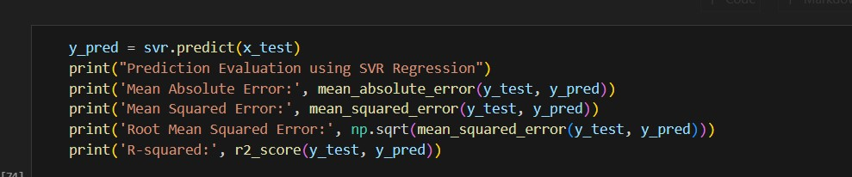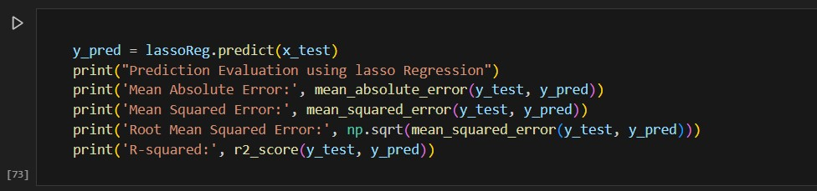

|  |  |
| --- | --- |
| Date | 09 JULY 2024 |
| Team ID | 740027 |
| Project Title | Evolving efficient classification patterns in  Lymphography |
| Maximum Marks | 4 Marks |

**Initial Model Training Code, Model Validation and Evaluation Report**

The initial model training code will be showcased in the future through a screenshot. The model validation and evaluation report will include classification reports, accuracy, and confusion matrices for multiple models, presented through respective screenshots.

**Initial Model Training Code:**

**Model Validation and Evaluation Report:**

**Model**

**Classification Report**

**Accuracy**

Random Forest

0.86

Linear

regression

0.30

Lasso

regression

-

1.42

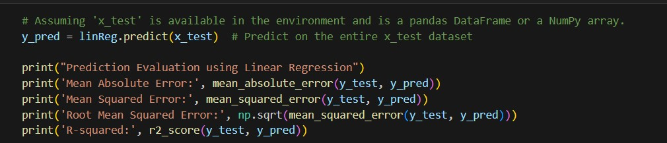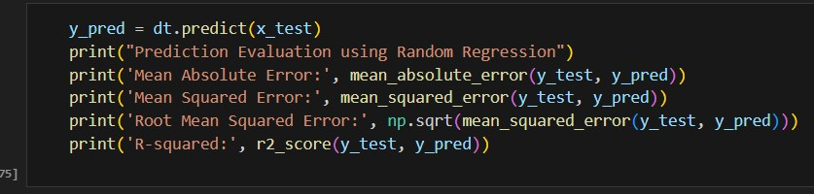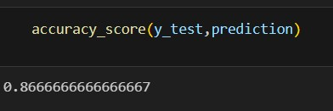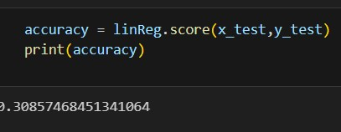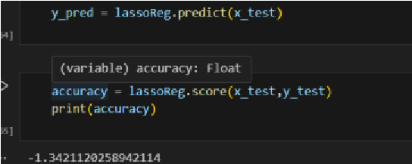

|  |  |  |
| --- | --- | --- |
| Decision tree |  | -8.92 |